Project Overview: Restaurant Success Prediction Framework

Objective & Decision Framework
The objective of this project is to develop an investment screening system designed to identify viable investment candidates in European restaurant markets.
The system was developed for a risk-averse investment environment managing Cost Asymmetry: the financial loss of a False Positive (failed investment) is significantly higher than the opportunity cost of a False Negative (missed investment). Consequently, the system is optimized for High-Confidence Selection rather than general classification accuracy. The framework intentionally sacrifices market coverage to maximize decision quality, targeting an 80% precision benchmark.
Success was operationally defined as restaurants with an average TripAdvisor rating greater than 4.0, transforming the prediction task into a binary classification problem.

Data Processing & Quality Filters
To ensure a reliable foundation for decision-making, the following data filters were implemented:
Statistical Threshold: Establishments with fewer than 20 reviews were excluded to ensure that the target variable was built on accurately represented businesses.
Leakage Removal: Post-launch performance metrics (e.g., popularity rankings and specific user feedback) were removed to maintain the system's validity as a pre-investment screening tool.
Economic Context Imputation: Missing price levels were filled using country-level medians, preserving the local economic relevance of the data.
Missing Indicator Strategy: Missing operational attributes were supplemented with binary indicator features, allowing the model to learn whether the absence of information itself carried predictive value.

In the graph below you can see the distribution of the target variable:

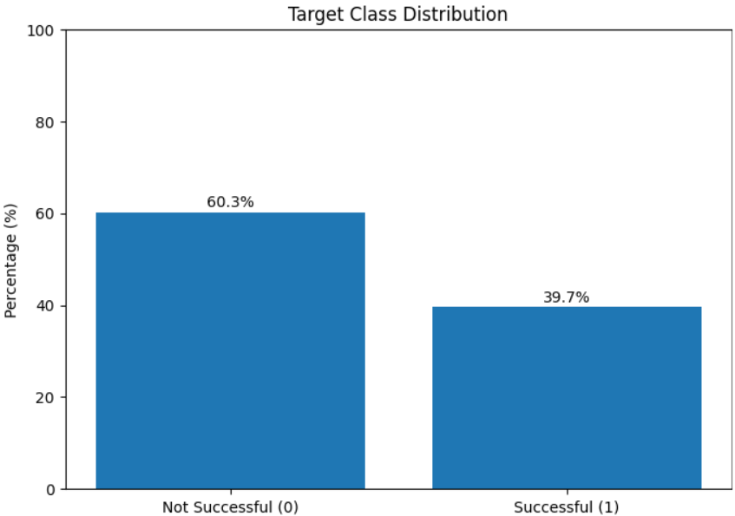

Key Predictive Drivers
Feature Engineering:
Cuisine Diversity: Used to identify operational complexity and market positioning.
Brand Factor (Is Chain): Distinguishes standardized franchises from independent businesses based on historical rating stability.
Feature importance analysis showed that the engineered variables contributed measurable predictive value to the final model.

Top 10 most influential features based on Random Forest feature importance
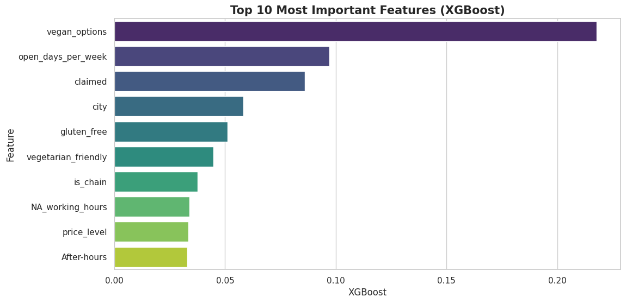

Feature Selection:
Feature importance analysis indicated that some encoded features showed relatively low standalone importance.
However, they were retained because they represent meaningful domain-specific categories (e.g., cuisine groupings) that may contribute predictive value collectively within the overall feature set.

Validation Framework
A dedicated 70-15-15 Train/Dev/Test split was utilized to ensure statistically stable evaluation on unseen data.
Given the dataset scale (~520K observations), a holdout validation strategy provided sufficient statistical stability while maintaining computational efficiency.
The Test set remained completely untouched until final evaluation to preserve a strict blind-testing protocol.
Stratified splitting was applied to preserve the target class distribution across Train, Dev, and Test subsets. The target variable (great_restaurant) remained stable at approximately 39.7% across all splits, ensuring statistically consistent evaluation on unseen data.

Handling missing values
Missing numerical values were imputed using country-level median values, allowing the model to preserve local economic context while maintaining data consistency across different markets.

Encoding & Representation Strategy
High-cardinality geographic variables were processed using Target Encoding to capture regional behavioral trends while mitigating overfitting risk.
Encoding statistics were calculated exclusively on the training set to prevent data leakage.
Cuisine categories were consolidated into broader representations using a custom transformation pipeline, including separate handling for rare categories and missing values.

System Evaluation & Model Selection
Multiple tree-based models were benchmarked to evaluate the trade-off between predictive power and precision stability.
Model Selection Table:

Model | Accuracy | Precision | Recall | f1-score | AUC
Decision Tree (Baseline) | 0.673502 | 0.656334 | 0.366872 | 0.470659 | 0.620556
Random Forest | 0.69402 | 0.669782 | 0.447026 | 0.536189 | 0.651371
Gradient Boosting | 0.694485 | 0.656147 | 0.478636 | 0.553507 | 0.657214
XGBoost | 0.694282 | 0.655622 | 0.478786 | 0.553421 | 0.657072
AdaBoost | 0.659517 | 0.66047 | 0.286928 | 0.400059 | 0.595182

Model Selection: Random Forest was chosen for its performance stability and robustness. Its architecture enables more stable threshold optimization compared to more complex, less interpretable ensembles.
Precision vs. Performance Trade-off: While the ROC-AUC remains moderate, this is a byproduct of prioritizing High-Confidence Selection as the primary business metric. The system's value lies in its high-confidence filtering capability rather than its broad classification performance.
Threshold Optimization: A classification threshold of 0.6641 was derived from the validation set to achieve the required 80% precision rate.
Precision-Recall trade-off used for threshold optimization
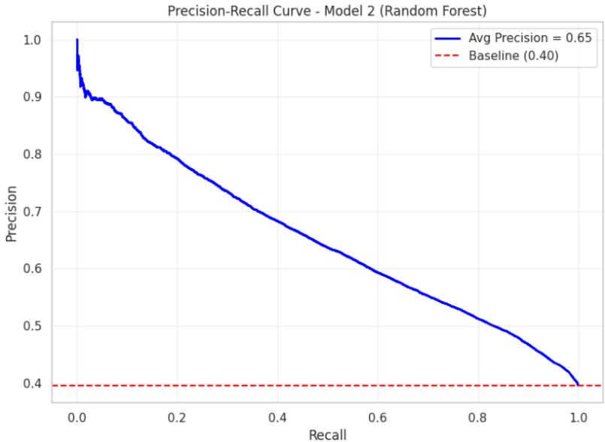

Quantitative Performance Summary
The table below represents the system's performance across all data sets. The minimal variance between the Validation and Test sets is a strong indication of the system's generalization capability on unseen data.

Metric | Train_Set | Dev_Set | Test_Set
Precision (High-Confidence Selection) | 0.86 | 0.82 | 0.81
Recall (Market Coverage) | 0.18 | 0.16 | 0.16
Accuracy | 0.66 | 0.65 | 0.65
ROC-AUC | 0.58 | 0.57 | 0.57

Business Impact: By maintaining a 81% precision rate on unseen data, the system effectively reduces exposure to False Positives. In practice, an 80% precision rate means that 4 out of 5 investments flagged by the system are historically aligned with successful outcomes.

